I like Trains
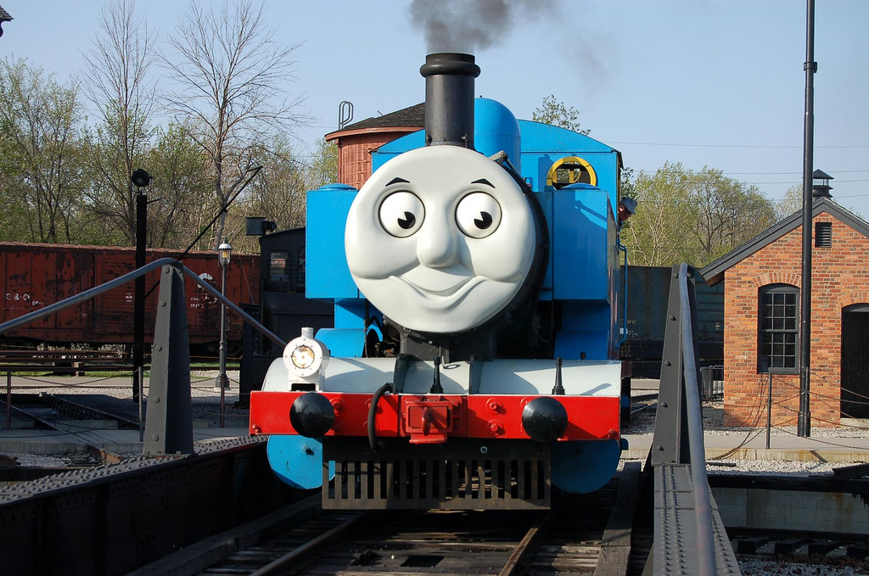
I like Trains
I Like Trains CHOO CHOO

http://www.thomasandfriends.com/en-us/

- Trains go choo choo.
- Woot woot
  - Railroad.
  - The trains have faces.
    - ONE is named thomas
    - One is named percy.
There is a mayor.
ONe day he needed help.
He wanted thomas to help.
Percy also wanted to help.
So he did help.
THey were all happy.
The trains are cool.
There are 73 words on this document.

